Robert Doyt Tickle
August 13, 1914 – May 31, 1971

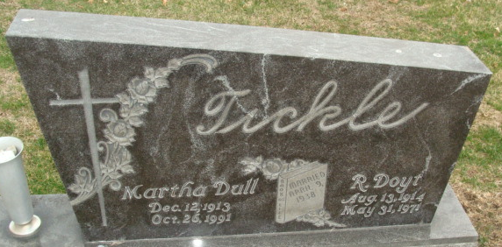
Photo by Alicia Kneuss

Doyt Tickle Dies Monday
Doyt R. Tickle, 56,of 814 North Jefferson Street, Van Wert, O., died suddenly of an apparent heart attack at 8:45 a.m. (EDT) Monday while working at Van Wert County's old landfill. Mr. Tickle had been employed as an electrical technician for 25 years at Dustman's Appliance & Furniture, and had been a Van Wert city employee for nine years.
Born at Wren, O., Aug. 13, 1914, he was a son of Mahlon and Effie Tague-Tickle, and had been a resident of Van Wert for 31 years. He was married to Martha Dull on April 9, 1938. Mr. Tickle was a member of the United Brethren in Christ Church at Van Wert.
Surviving are his wife; one daughter, Miss Shirley Tickle at home; two half-sisters, Mrs. Irene Putman and Mrs. May Bienz, both of Van Wert; and three half-brothers, Otis Byer and Cloyd Byer, both of Willshire, O., and Eugene Byer of Kansas.
Funeral rites will be held at 10:30 a.m. (EST) Thursday at the Zwick Funeral Home, with Rev. Van Giesler officiating. Burial will be in the Decatur Cemetery. Friends may call at the funeral home after 7 p.m. today until time of the services.
Decatur Daily Democrat, Adams County, IN
Tuesday, June 1, 1971

