Martha Mae (Dull) Tickle
December 12, 1913 – October 26, 1991

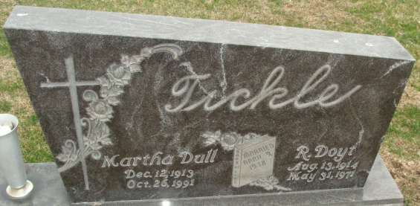
Photo by Alicia Kneuss

Martha M. Tickle, 77, of Wren, Ohio, died Saturday at home. The Wren native was a former employee of the Marsh Foundation and widow of R. Doyt, who died in 1971.
Surviving is a daughter, Shirley Tickle of Wren; and a sister, Chole Simerman of Decatur.
Services are 1 p.m. tomorrow in Zwick-Sefton & Jahn Funeral Home, Decatur, where calling is 9 a.m. to 1 p.m. tomorrow. Burial will be in Decatur Cemetery.
Preferred memorials are gifts to Wren Emergency Medical Service or Van Wert (Ohio) Visiting Nurses & Hospice.

News-Sentinel, Allen County, Indiana
Monday, October 28, 1991

**
U.S., Social Security Applications and Claims Index, 1936-2007
Name Martha Mae Tickle
[Martha M Tickle]
[Martha Mae Dull]
Gender Female
Race White
Birth Date 12 Dec 1913
Birth Place Wren Ohio VA, Ohio
Death Date 26 Oct 1991
Father Charles C Dull
Mother Bessie E Bell
SSN xxx
Notes Jan 1943: Name Listed As Martha Mae Tickle; 03 Jun 1993: Name Listed As Martha M Tickle

