Leroy Brooks Tickle
August 19, 1922 – April 4, 2006

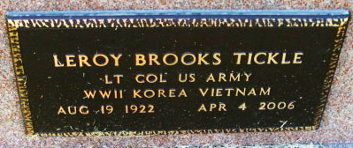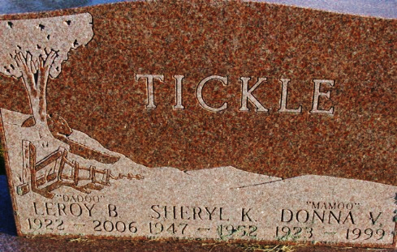
Photo by Alicia Kneuss

Leroy Brooks Tickle
in the U.S., Cemetery and Funeral Home Collection, 1847-Current
Name Leroy Brooks Tickle
Gender Male
Death Age 83
Birth Date 19 Aug 1922; Birth Place Van Wert, Ohio
Marriage Date 13 Mar 1943; Marriage Place San Diego, California
Residence Place Houston, Texas
Death Date 4 Apr 2006; Death Place Houston
Burial Date 11 Apr 2006
Father Jesse Clyde Tickle
Mother Josephine Tickle
Spouse Donna Virjean Kraft
Child Shelia Kay Stigall, Korby Leigh Bole
Siblings Regis Tickle, Eleanor Prichard, Clara Davis, Ormal Russell, Jeanette Krugh, Thelma Kline
**
U.S., Social Security Applications and Claims Index, 1936-2007
Name Leroy Brooks Tickle
[Leroy B Tickle]
Gender Male
Race White
Birth Date 19 Aug 1922
Birth Place Ohio City VA, Ohio
Death Date 4 Apr 2006
Father Jesse C Tickle
Mother Josephine Fryer
SSN xxx
Notes Oct 1940: Name Listed As Leroy Brooks Tickle; 28 Apr 2006: Name Listed As Leroy B Tickle

