Donna Virjean (Kraft) Tickle
December 3, 1923 – September 29, 1999

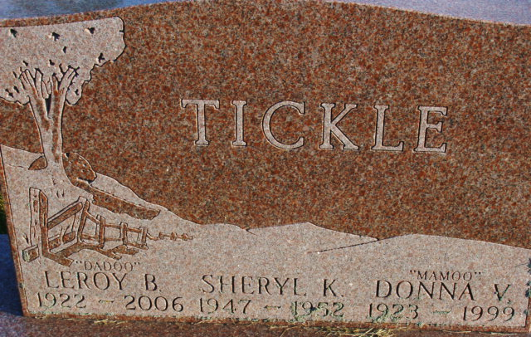
Photo by Alicia Kneuss

Donna Virjean Tickle
in the Texas, U.S., Death Index, 1903-2000
Name Donna Virjean Tickle
Death Date 29 Sep 1999
Death County Harris
**
U.S., Social Security Applications and Claims Index, 1936-2007
Name Donna Virjean Kraft
[Donna Kraft Tickle]
[Donna Tickle]
Gender Female
Race White
Birth Date 3 Dec 1923
Birth Place Spencerville, Ohio
Death Date 29 Sep 1999
Father Harman F Kraft
Mother Lois M Townsend
SSN xxx
Notes : Name Listed As Donna Virjean Kraft; : Name Listed As Donna Kraft Tickle; 08 Oct 1999: Name Listed As Donna V Tickle

