Earl L. Thrailkill
November 2, 1882 – February 3, 1945

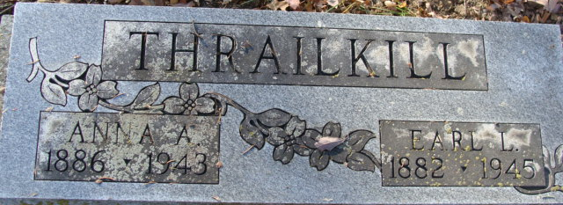
Photo by Alicia Kneuss

Earl L Thrailkill
in the Indiana, U.S., Death Certificates, 1899-2017
Name Earl L Thrailkill
Gender Male
Race White
Marital Status Married
Age 62
Birth Date 2 Nov 1882
Birth Place Indiana
Death Date 3 Feb 1945
Death Place Marion, Grant, Indiana, USA
Death Registration Date 1945
Father David Thrailkill
Mother Charity
Spouse Myrtle
Informant Mrs. Earl Thrailkill
Burial February 6, 1945; Decatur Cemetery; Decatur, Indiana

