Anna A. (Bender) Thrailkill
March 25, 1886 – June 12, 1943

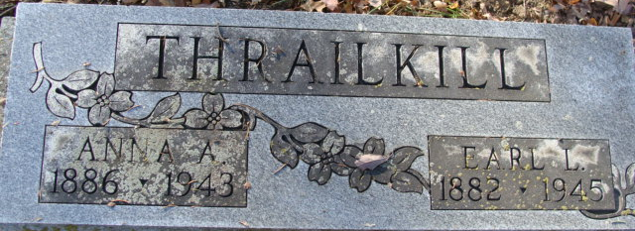
Photo by Alicia Kneuss

Anna Thrailkill
in the Indiana, U.S., Death Certificates, 1899-2017
Name Anna Thrailkill
[Anna Bender]
Gender Female
Race White
Marital Status Married
Age 56
Birth Date 25 Mar 1887 (sic)
Birth Place Adams County, Indiana
Death Date 12 Jun 1943
Death Place Marion, Grant, Indiana, USA
Death Registration Date 1943
Father Fred Bender
Mother Jennie Mager
Spouse Earl Thrailkill; age 56
Informant Earl Thrailkill; Marion, Indiana
Burial June 15, 1943; Decatur Cemetery; Decatur, Indiana

