William Junior Thornton
May 7, 1913 – July 3, 1975

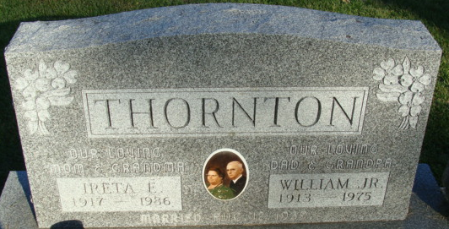
Photo by Alicia Kneuss

William J Thornton
in the Indiana, U.S., Death Certificates, 1899-2017
Name William J Thornton
Gender Male
Race White
Marital Status Married
Age 62
Birth Date 7 May 1913
Birth Place Ohio
Death Date 3 Jul 1975
Death Place Bluffton, Wells, Indiana, USA
Death Registration Date 1975
Father William J Thornton
Mother Mary Kelly
Spouse Ireta Fairchild
Informant July 6, 1975; Decatur Cemetery; Decatur, Indiana

