William Allen Thornton
October 15, 1880 – September 3, 1932

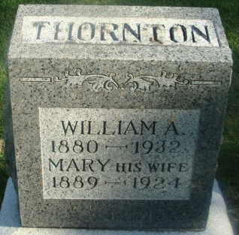
Photo by Alicia Kneuss

William Allen Thamton
in the Indiana, U.S., Death Certificates, 1899-2017
Name William Allen Thornton
Gender Male
Race White
Marital Status Married
Age 51
Birth Date 15 Oct 1880
Birth Place Indiana
Death Date 3 Sep 1932
Death Place Decatur Hills, Adams, Indiana, USA
Death Registration Date 1932
Father Walter Thornton
Mother Ana Nessick
Spouse Hattie
Informant Mrs. William Thornton; Decatur, Indiana
Burial September 6, 1932; Decatur Cemetery

