Sharon L. (Thompson) Thornton
January 11, 1948 – June 14, 2011

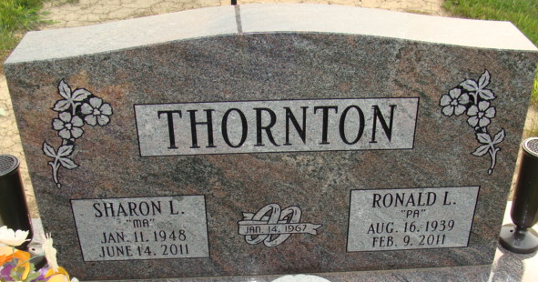
Photo by Alicia Kneuss

Sharon L. Thornton, 63, of Decatur, died on Tuesday, June 14, 2011, at the nursing center in Woodcrest Retirement Community. She was born on January 11, 1948 in Greenville, Ohio, to Charles and Doris (Kemp) Thompson. On January 14, 1967, she married Ronald Thornton. He preceded her in death on February 9, 2011.
She had worked for the Adams County Emergency Management Agency for many years.
She is survived by her mother, Doris Stiver of Xenia, Ohio; a son Douglas (Stephanie) Thornton of Decatur; a sister Nancy Brooks of Xenia, Ohio; three grandchildren, Mrs. Richard (Brittany) Parrish II, Gregory Thornton and Cody Thornton, all of Decatur. and two great-grandchildren, Charles A. Lopez and Addison G. Parrish of Decatur. She was also preceded in death by her father.
Funeral services will be held on Friday, June 17, 2011 at 3 p.m. with calling from 1-3 p.m. at Haggard-Sefton and Hirschy Funeral Home. Pastor Dan York will be officiating. Burial will be in Decatur Cemetery.
Memorials are to the Diabetes Fund within the Adams County Community Foundation.

Decatur Daily Democrat, Adams County, Indiana
Wednesday, June 15, 2011

