Ronald L. Thornton
August 16, 1939 – February 9, 2011

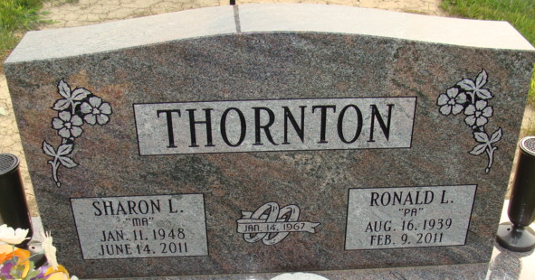
Photo by Alicia Kneuss

Ronald Thornton, 71, of Decatur, died on Wednesday, February 9, 2011 at Lutheran Hospital in Fort Wayne. Ronald was born on August 16, 1939 in Xenia, Ohio, to Edward and Maxine (Elliott) Thornton Sr. He married Sharon L. (Thompson) Thornton on January 14, 1967.
Ron was a lifetime member of Moose Lodge 1311 in Decatur and a longtime volunteer for the Adams County Emergency Management Agency. He was a forklift driver at Phelps Dodge in Fort Wayne for 34 years and retired in 2005.
Surviving is his wife, Sharon L. Thornton of Decatur; one son, Douglas C. (Stephanie) Thornton of Decatur; his special canine companion. "Cookie"; a brother Jerry Wayne Thornton of Xenia, Ohio; two sisters, Diana Charles of Xenia, Ohio and Kay Cline of Dayton Beach, Florida; three grandchildren, Brittany (Richard) Parrish II, Gregory Thornton and Cody Thornton, all of Decatur; two great-grandchildren; Charles A. Lopez and Addison G. Parrish. He was preceded in death by a brother, Edward Thornton Jr.
Visitation is 2-5 and 6-8 p.m. on Monday, February 14, 2011, at Haggard and Sefton Funeral Home in Decatur and two hours prior to services. A Moose service will be held at 8 p.m. on Monday in the funeral home. Funeral services will be at 2p.m. on Tuesday, February 15, 2011 in the funeral home, with Rev. Michael Heinbaugh officiating. Burial will be in the Decatur Cemetery.
Memorials are to Mooseheart.

Decatur Daily Democrat, Adams County, Indiana
Friday, February 11, 2011

