Mary (Kelly) Thornton
March 6, 1889 – September 26, 1924

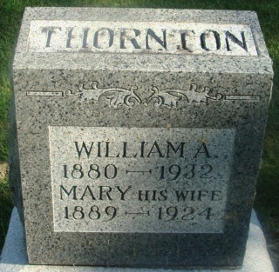
Photo by Alicia Kneuss

MRS. THORNTON DIED LAST NIGHT
Mother of Four Young Children Died After Short Illness
Mrs. Mary Thornton, age 35 years, a resident of Decatur for the last ten years, died at the Adams County Memorial hospital at 8:15 o'clock last night. Death was due to a complication of diseases affecting the bowels and stomach. Mrs. Thornton was taken ill last Sunday and was removed from her home, 1024 West Adams Street, to the hospital on Thursday.
Mrs. Thornton was a daughter of Mr. and Mrs. Henry Kelly, and was born in Pittsburgh, Pennsylvania, March 6, 1889. She was married to William Thornton sixteen years ago. They moved to Decatur from Bucyrus, Ohio, ten years ago. Mrs. Thornton was a member of the First Methodist Church.
She is survived by her husband; four children, Berniece, age 15, Ruth, age 13, William, age 10, and Marjorie Louise, age 3; one brother, John Kelly of Pittsburgh; and two sisters, Mrs. Anna Bernham, of Pittsburgh, Pennsylvania, and Mrs. Wise, of Wheeling, West Virginia.
Funeral services will be held from the residence at 9 o'clock and from the First Methodist Church at 2:30 o'clock Monday afternoon, the Rev. U. S. A. Bridge, pastor of the Methodist Church, officiating. Burial will be made in the Maplewood Cemetery.
Decatur Daily Democrat, Adams County, Indiana
Saturday, September 27, 1924

