Ireta Ella (Fairchild) Thornton
November 27, 1917 – September 28, 1986

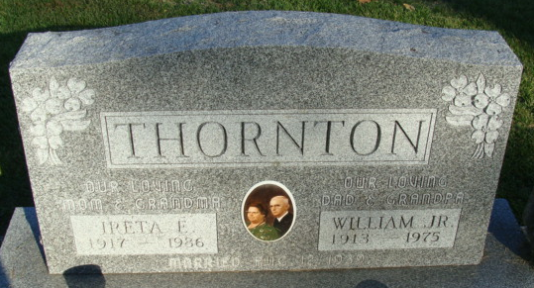
Photo by Alicia Kneuss

Ella Ireta Thornton
in the Indiana, U.S., Death Certificates, 1899-2017
Name Ella Ireta Thornton
[Ella Ireta Fairchild]
Gender Female
Race White
Marital Status Widowed
Age 68
Birth Date 27 Nov 1917
Birth Place Indiana
Death Date 28 Sep 1986
Death Place Decatur, Adams, Indiana, USA
Death Registration Date 1986
Father Thomas Fairchild
Mother Rose Scott
Informant Donald Thornton; son; Fort Wayne, Indiana
Burial October 1, 1986; Decatur Cemetery; Decatur, Indiana

