Jane (Passwaters) Thornburg
June 1, 1834 – February 12, 1927

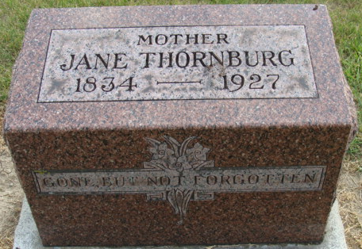
Photo by Alicia Kneuss

Jane Thornburg
in the Indiana, U.S., Death Certificates, 1899-2017
Name Jane Thornburg
[Jane Passwaters]
Gender Female
Race White
Marital Status Widowed
Age 92
Birth Date 1 Jun 1834
Birth Place Janesville, Ohio
Death Date 12 Feb 1927
Death Place Denatur, Adams, Indiana, USA
Death Registration Date 1926-1927
Father Wm Passwaters
Mother Unknown
Informant Ed Fulton; Decatur, Indiana
Burial February 14, 1927; Decatur Cemetery
**
Jane Passwaters from tree Pendleton Family Tree
Birth 1 Jun 1834 Muskingum, Ohio, USA
Marriage 15 Aug 1871 Adams, Indiana, USA
Residence 1920 Decatur, Adams, Indiana, USA
Death 12 Feb 1927 Decatur, Adams, Indiana, USA
Father William Passwaters (1810-1880)
Mother Mary Morrow
Spouse John Fulton (Born 1810)
Spouse Milton Thornburg

