Mary E. (Emerson) Thompson
June 28, 1847 – November 26, 1911

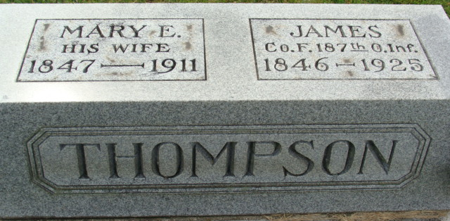
Photo by Alicia Kneuss

Mary E. Emerson from tree -If-Not-For-Them
Birth 28 Jun 1847 Union, Ohio, USA
Marriage 3 Feb 1868 Van Wert, Ohio, USA
Residence 1910 Fort Wayne, Allen, Indiana, USA
Death 26 Nov 1911 Allen, Indiana, USA
Father Thomas Emerson (1789-1870)
Mother Delila Henry (1804-1871)
Spouse James Thelopilus Thompson (1847-1925)

