Mary Alice (Williams) Thompson
June 8, 1885 – January 30, 1933

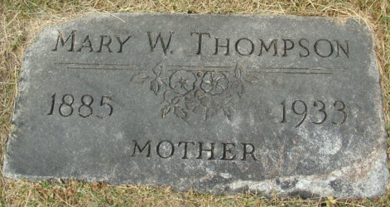
Photo by Alicia Kneuss

Mary Alice Thompston
in the Indiana, U.S., Death Certificates, 1899-2017
Name Mary Alice Thompston [sic]
[Mary Alice Williams]
Gender Female
Race White
Marital Status Married
Age 47
Birth Date 8 Jun 1885
Birth Place Pennsylvania
Death Date 30 Jan 1933
Death Place Decatur, Adams, Indiana, USA
Death Registration Date 1933
Father George Williams
Mother Eula Dickens
Spouse Harry Thompston
Informant Harry W. Thompson; Decatur, Indiana
Burial February 2, 1933; Decatur Cemetery

