John M. Thompson
March 14, 1878 – January 12, 1931

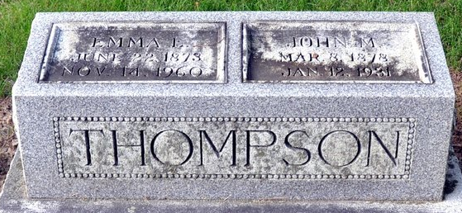
Photo by Deb Curry

John Thompson Dies Today
Decatur Resident Succumbs After Long Siege of Tuberculosis
John Thompson, 52, for many years a resident of this city, died at his home, 219 North Eighth street, at 3 o'clock this morning. Death was due to tuberculosis, from which the deceased had suffered since last March. He was bedfast for the last three months, and death was expected for the past several days.
Mr. Thompson was employed at the local General Electric plant until his illness last March. He was a member of the local Moose Lodge, and the American Insurance Union of Fort Wayne, for many years.
The deceased was born at Paulding, Ohio, March 14, 1878, the son of James and Elizabeth Thompson. Thirty years ago, he was united in marriage to Emma Bowers-Stalter, who survives, together with two sons, Forrest and Raymond Thompson, and a stepson, Dorus Stalter, of this city. One grandchild and 4 step-grandchildren also survive. One daughter preceded the deceased in death.
Surviving are one ETS.As ET les (that is what is in the paper) Thompson of Mansfield, O., and three sisters, Mrs. Belle Huise of Union City, Mrs. Lattie Mann and Mrs. Alma Albright of Fort Wayne.
Funeral services will be held Wednesday afternoon at 2 o'clock at the home on Eighth street. Rev. B. H. Franklin, pastor of the Methodist Episcopal Church, will officiate and burial will be made in the Decatur Cemetery.
Decatur Daily Democrat, Adams County, Indiana
Monday, January 12, 1931
**
Indiana, U.S., Death Certificates, 1899-2017
Name John M. Thompson
Gender Male
Race White
Marital Status Married
Age 52
Birth Date 14 Mar 1878
Birth Place Ohio
Death Date 12 Jan 1931
Death Place Decatur, Adams, Indiana, USA
Death Registration Date 1931
Father James Thompson
Mother Elizabeth Brown
Spouse Emma
Informant Mrs. Emma Thompson
Burial January 14, 1931; Decatur Cemetery

