Joan D. Thompson
March 6, 1936 – January 21, 2022

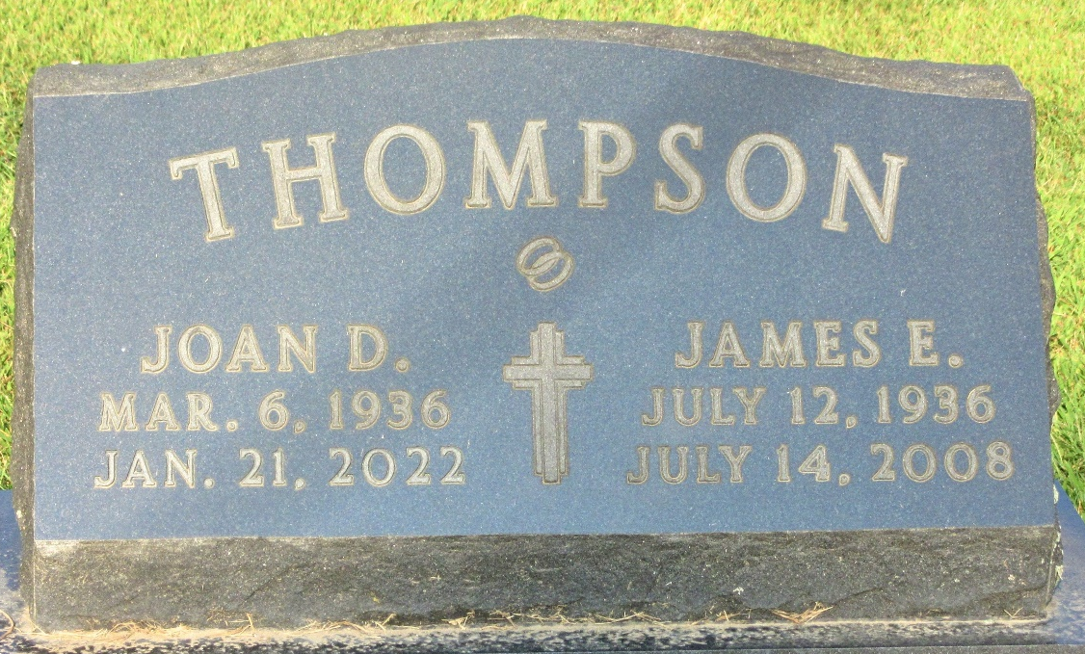
Photo by PLS

No further information found at this time

