James T. Thompson
November 17, 1846 – April 18, 1925

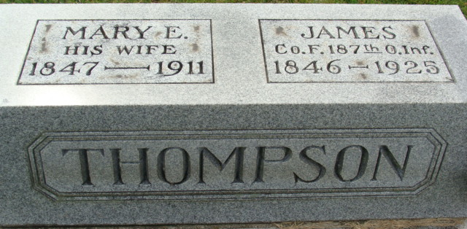
Photo by Alicia Kneuss

James Thompson
in the Indiana, U.S., Death Certificates, 1899-2017
Name James Thompson
Gender Male
Race White
Marital Status Widowed
Age 77
Birth Date 17 Nov 1847
Birth Place Ohio
Death Date 18 Apr 1925
Death Place Fort Wayne, Allen, Indiana, USA
Death Registration Date 1925
Father Robert Thompson
Mother Lydia Hattery
Spouse Mary E.
Informant Mrs. Alma Albright
Burial April 20, 1925; Decatur, Indiana

