James Elmer Thompson
July 12, 1936 – July 14, 2008

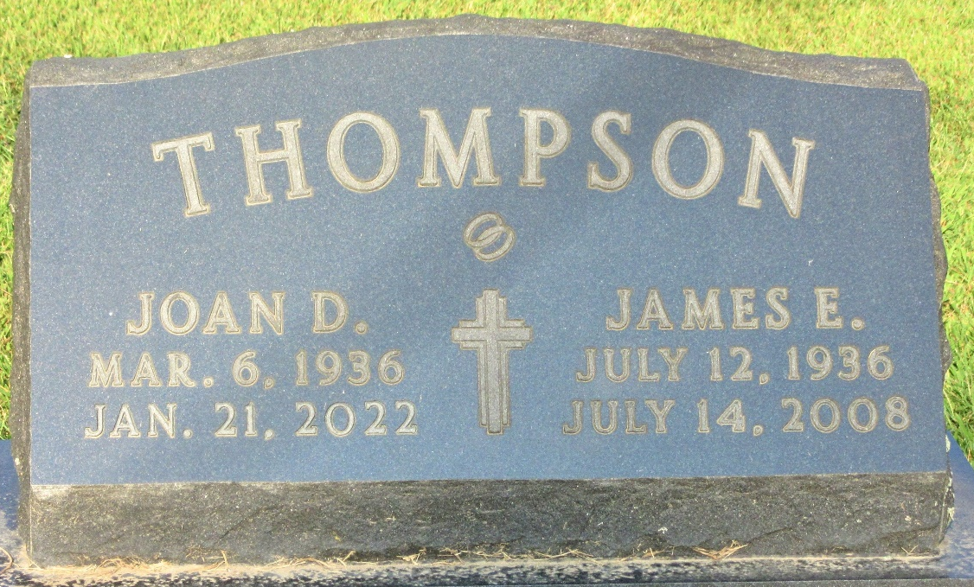
Photo by PLS

James Elmer Thompson from tree Howell Family Tree
Birth 12 Jul 1936
Death 14 Jul 2008
Father Milo J Thompson (1901-1984)
Mother Frances B Henthorn (1904-1980)

