Rev. Harry Wright Thompson
April 5, 1886 – September 22, 1944

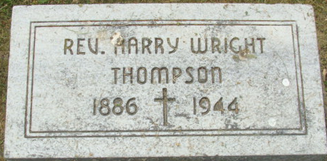
Photo by Deb Curry

Harry Wright Thompson
in the Indiana, U.S., Death Certificates, 1899-2017
Name Harry Wright Thompson
Gender Male
Race White
Marital Status Married
Age 56
Birth Date 5 Apr 1886
Birth Place Latrobe, Pennsylvania
Death Date 22 Sep 1944
Death Place Decatur, Adams, Indiana, USA
Death Registration Date 1944
Father Robert Thompson
Mother Barbara
Spouse Lavon
Informant Mrs. Harry Thompson
Burial September 24, 1944; Decatur Cemetery; Decatur, Indiana

