Emma (Bower) Thompson-Gauze
June 22, 1873 – November 14, 1960

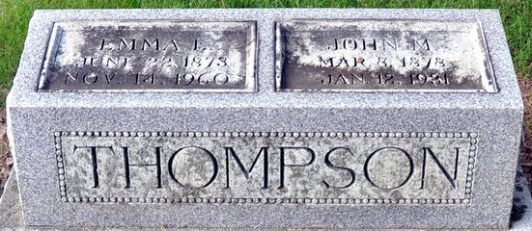
Photo by Deb Curry

MRS. EMMA GAUZE DIES LATE MONDAY
DECATUR WOMAN WAS IN BERNE NURSING HOME 18 MONTHS
Mrs. Emma Gauze, 88, of Decatur, died at 11:50 p.m. Monday in the Adams County Memorial Hospital, where she had been a patient since Thursday. She had been in the Berne Nursing Home for 18 months. Mrs. Gauze was a member of the First Methodist Church in Decatur.
Surviving are two sons, Dorus Stalter, Decatur, and Forrest Thompson, Pontiac, Mich.; four grandchildren, seven great-grandchildren and a great-great-grandchild.
Services will be conducted at 1 p.m. Thursday in the Zwick Funeral Home, with burial in the Decatur Cemetery. Friends may call at the funeral home.

Adam County Historical Museum, Adams County, Indiana
January 1958 – December 1960 Scrapbook, image 51
Handwritten date: Wednesday, November 16, 1960
**
Indiana, U.S., Death Certificates, 1899-2017
Name Emma Gauze [Emma Bower]
Gender Female; Race White
Marital Status Widowed
Age 88
Birth Date 22 Jun 1873; Birth Place Ohio
Death Date 14 Nov 1960
Death Place Decatur, Adams, Indiana, USA
Father Jonathan Bower
Mother Lydia Spade
Informant Dorus Stalter; son; Decatur, Indiana
Burial November 17, 1960; Decatur Cemetery; Decatur, Indiana

