Edna Corinna Thompson
May 10, 1906 – December 21, 1918

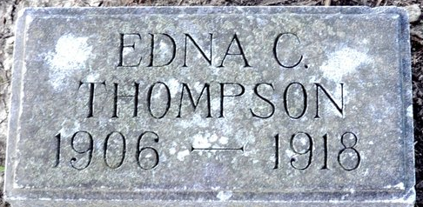
Photo by Deb Curry

Edna Corinna Thompson
in the Indiana, U.S., Death Certificates, 1899-2017
Name Edna Corinna Thompson
Gender Female
Race White
Marital Status Single
Age 11
Birth Date 10 May 1906
Birth Place Decatur, Indiana
Death Date 21 Dec 1918; typhoid fever
Death Place Decatur, Adams, Indiana, USA
Death Registration Date 1918
Father ?? M Thompson
Mother ?? E Bowers
Informant Can't read
Burial December 23, 1918; Decatur Cemetery
**
Edna Corinna Thompson from tree Where Do I Begin?
Birth 10 May 1906 Decatur, Adams, Indiana, USA
Residence 1910 Decatur, Adams, Indiana, USA
Death 21 Dec 1918 Decatur, Adams, Indiana, USA
Father John McKee Thompson (1878-1931)
Mother Emma Elizabeth Bower (1873-1960)

