Daniel J. Thompson, Sr.
October 15, 1950 – January 6, 2010

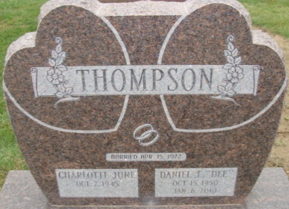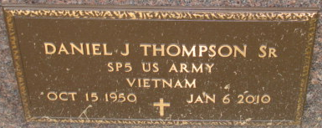
Photo by Alicia Kneuss

Daniel J. Thompson, Sr., 59, of Monroe, passed away Wednesday, Jan. 6, 2010, 7:05 a.m., at his residence following an extensive and courageous battle with cancer. Born Oct. 15, 1950 in Fort Wayne, he was the son of the late Joseph Albert and Rosetta Orpha (Jones) Thompson. He married C. June Hill on April 15, 1972, she survives in Monroe.
He served his country during the Vietnam War. He enlisted in the U.S. Army National Guard in March of 1969 and was honorably discharged in March of 1973. He retired from Rea Magnet Wire (formerly Phelps Dodge) in 2009 after 36 years of service as a production worker. He was a member of North Adams Church of Christ in Decatur.
Also surviving are his daughter, Jackie (John) Krudop of Fort Wayne; son, Daniel J. Thompson, Jr. of Monroe; sisters, Judy Fraze of Hartford City, Ind., Teresa (Jerry) Cramer of Fort Wayne and Rosemary (Charles) Whitaker of Fort Wayne; five grandchildren, Matthew Krudop, Katrina Krudop, Jerod Krudop, Jordan Krudop and Mia Thompson.
Service is 10:30 a.m. Saturday at Zwick & Jahn Funeral Home, Decatur with visitation one hour prior to service. Jim Voglewede officiating. Visitation also from 4 to 8 p.m. Friday at the funeral home. Military graveside services will be conducted by the Adams Post 43 American Legion Color Guard. Burial will be in Decatur Cemetery.
Preferred memorials to Family Hospice and Palliative Care or North Adams Church of Christ.

Zwick Funeral Home, Adams County, Indiana
January 7, 2010

