Charlotte June (Hill) Thompson
October 2, 1945 -

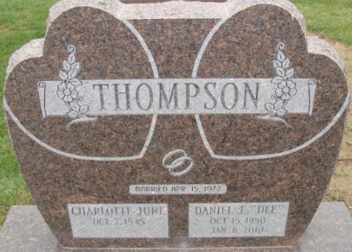
Photo by Alicia Kneuss

