Catherine (Kirby) Thompson
March 21, 1843 – November 8, 1923

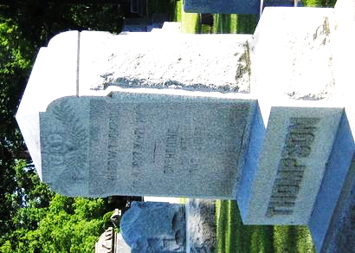
Photo by Mike Horn

PIONEER DIES IN THIS CITY
Katherine Kirby Thompson Dies At Home of Her Daughter, Mrs. Dorwin
Katherine Kirby Thompson, 79, known and loved by hundreds of Adams County people, died at the home of her daughter, Mrs. Maude Dorwin, on North First Street, at 1:15 o’clock this morning. Death was due to carcinoma, with which she suffered since April. However, Mrs. Thompson had not been confined to her bed and it was not until after breakfast yesterday morning that she consented to take to her bed.
Funeral services will be held from the Dorwin home on North First Street at 2:30 o’clock Saturday afternoon, the Rev. S. I. Zechiel, pastor of the Monroe Methodist Church, officiating. Burial will occur in the Decatur Cemetery.
Katherine Kirby, daughter of Ephraim and Elizabeth Kirby, was born in Carroll County, Ohio, March 21, 1844. The Kirby family were early settlers in Carroll County, coming there from the state of Pennsylvania. On April 9, 1865, Katherine was married to Howard Thompson, a native of Carroll County; Ohio. In 1868, Mr. and Mrs. Thompson moved to Adams County, Indiana, and settled on a farm one mile east of Monroe, where they resided until Mr. Thompson’s death, May 21, 1901.
Came to Decatur in 1901
Following her husband’s death, Mrs. Thompson moved to Decatur and since then has resided with her daughter, Mrs. Dorwin. She was a member of the Methodist Episcopal Church at Monroe and was a charter member of the Rebekah Lodge in this city. Mrs. Thompson was possessed of a wonderful disposition, and it is said of her that she did not have a single enemy. Her death removes one of the fine old pioneers of Adams County.
Five children were born to Mr. and Mrs. Thompson, all of whom survive. They are Elizabeth, wife of J. A. Hendricks, of Monroe; Frances E. Thompson, of Calvary, Canada; C. A. Thompson, of Aurora, Nebraska; Mrs. Maude Dorwin, of Decatur; and E. Kirby Thompson, of Van Wert, Ohio. Mrs. Thompson is survived by two brothers also, namely, Col. Harry W. Kirby, former editor of the Decatur Journal and now of Zephyr Hills, Fla., and W. W. Kirby of Scio, Ohio. There are nine grandchildren and one great-grandchild.
Decatur Daily Democrat, Adams County, Indiana
Thursday, November 8, 1923
**
Indiana, U.S., Death Certificates, 1899-2017
Name Catherine Thompson
[Catherine Kirby]
Gender Female
Race White
Marital Status Widowed
Age 80
Birth Date 21 Mar 1843
Birth Place Ohio
Death Date 8 Nov 1923
Death Place Decatur, Adams, Indiana, USA
Death Registration Date 1923
Father Ephrim Kirby
Mother Elizabeth Biar
Informant Maude Dorwin; Decatur, Indiana
Burial November 10, 1923; Decatur Cemetery

