April Ann Thompson
March 8, 1961 – August 13, 2012

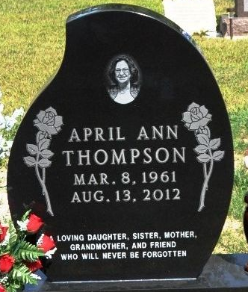
Photo by Deb Curry

April Ann Thompson
in the U.S., Cemetery and Funeral Home Collection, 1847-Current
Name April Ann Thompson
Gender Female
Death Age 51
Birth Date 8 Mar 1961
Birth Place Bryan, Ohio
Residence Place Decatur, Indiana
Death Date 13 Aug 2012
Death Place Van Wert, Ohio
Burial Place Decatur, Indiana
Father Eugene A. Thompson
Mother Mary S. Thompson
Child Starr Bell, Dustin Wolfe, Talon Wolfe, Robert Thompson-Witte
Siblings Terry Rennels, Martin Thompson, Brenda Sue Thieme, Cindy Lou Jackson, Monte Thompson

