Ruth Ellen (Cook) Thomas
March 28, 1901 – September 23, 1956

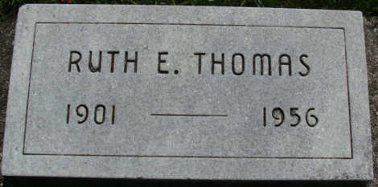
Photo by Alicia Kneuss

Mrs. Bryce Thomas Dies Early Sunday
Decatur Lady Dies After Long Illness
Mrs. Ruth Ellen Thomas, 55, wife of Bryce Thomas, principal of the Lincoln Elementary School, died early Sunday morning at her home, 222 South Third Street. She had been in failing health since 1940.
Mrs. Thomas, former teacher in the Decatur High School, was prominent in church, social and civic activities in this city until ill health confined her to her home.
She was a member of the First Methodist Church, the W.S.C.S. of the church, the Tri Kappa Sorority, Shakespeare Club, Research Club, the American Legion Auxiliary and Delta Sigma Epsilon, college sorority. She was a past president of the Decatur Woman’s Club, a former chairman of the Junior Red Cross, and one of the organizers of the Decatur Girl Scouts.
She was born in Blanchester, O., March 28, 1901, a daughter of James F. and Maude Hill-Cook, and was married to Bryce Thomas June 4, 1927.
Surviving in addition to her husband are her mother, who lives at Blanchester, O.; one son, Daniel Charles Thomas, a senior at Purdue University; one granddaughter, Danielle Thomas, of Richmond, and one brother, William Cook of Blanchester, O. One son preceded her in death.
Funeral services will be conducted at 2:30 p. m. Tuesday at the Zwick Funeral Home, the Rev. Virgil W. Sexton officiating. Burial will be in the Decatur Cemetery. Friends may call at the funeral home until time of the services.
Decatur Daily Democrat, Adams County, Indiana
Monday, September 24, 1956

