Philip Bryce Thomas, Jr.
January 12, 1929 – June 2, 1953

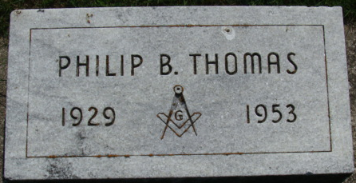
Photo by Alicia Kneuss

Phillip Bryce Thomas Jr
in the Indiana, U.S., Death Certificates, 1899-2017
Name Phillip Bryce Thomas Jr
Gender Male
Race White
Marital Status Married
Age 24
Birth Date 12 Jan 1929
Birth Place Indiana
Death Date 2 Jun 1953; suicide by hanging
Death Place Richmond, Wayne, Indiana, USA
Death Registration Date 1953
Father Pearlie Bryce Thomas
Mother Ruth Cook
Informant Louise Thomas; Richmond, Indiana
Burial June 5, 1953; Decatur Cemetery; Decatur, Indiana

