Pamela K. (Shelton) Thomas
November 2, 1951 – January 6, 2005

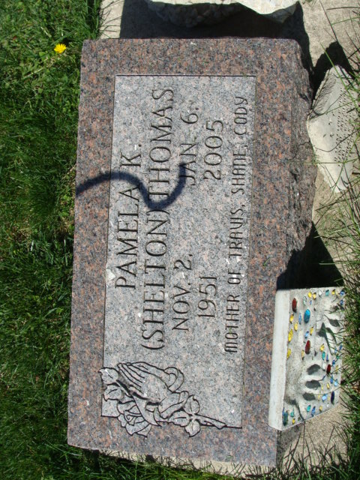
Photo by Alicia Kneuss

Pamela Thomas, 53
A worker at Peyton Northern in Bluffton, Pamela K. Thomas, 53, Decatur, died at 9:43 a.m. Thursday, Jan. 6 at Adams Memorial Hospital in Decatur.
Survivors include her mother, Norma Shelton, Decatur; three sons and two brothers, all of Decatur; one grandson and three step grandchildren.
Services will be held Monday at 11 a.m. at the Haggard & Sefton Funeral Home in Decatur. Calling hours are Sunday from 11 a.m. to 3 p.m. and for one hour prior to the service on Monday.
Preferred memorials to the Zion United Church of Christ or to Hospice of Northeast Indiana.

Bluffton News Banner, Wells County, Indiana
Friday, January 7, 2005

**
Pamela K. Thomas, 53, of Decatur, died Thursday, Jan. 6, 2005, 9:43 a.m., at Adams Memorial Hospital. Born Nov. 2, 1951, in Adams County, she was the daughter of the late George F. Shelton and Norma J. (Fox) Shelton, she survives in Decatur.
She attended Zion United Church of Christ. She was an avid Bellmont wrestling fan. She was a Returns Clerk for Peyton Northern, Bluffton.
Also surviving are three sons, Travis (Dawn) Thomas, Shane Thomas and Cody (Marci) Thomas, all of Decatur; two brothers, Brad Shelton and Todd Shelton, both of Decatur; one grandson; three step grandchildren.
Funeral service is 11 a.m. Monday at Haggard & Sefton Funeral Home, Decatur, with visitation one hour prior to service; The Rev. Randy Rossman officiating. Visitation also from 11 a.m. to 3 p.m. Sunday at the funeral home. Burial at Decatur Cemetery.
Memorials to Zion United Church of Christ or Hospice of Northeast Indiana.

News-Sentinel, Allen County, Indiana
Friday, January 7, 2005

