Opal N. (Gick) Thomas
May 22, 1894 – November 30, 1979

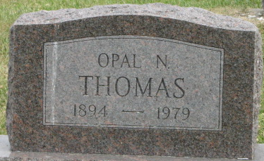
Photo by Deb Curry

Opal Thomas
in the Indiana, U.S., Death Certificates, 1899-2017
Name Opal Thomas
[Opal Gick]
Gender Female
Race White
Marital Status Widowed
Age 85
Birth Date 22 May 1894
Birth Place Indiana
Death Date 30 Nov 1979
Death Place Decatur, Adams, Indiana, USA
Death Registration Date 1979
Father Henry Gick
Mother Elizabeth
Informant Ruth Giessler; Decatur, Indiana
Burial December 3, 1979; Decatur Cemetery; Decatur, Indiana
**
Opal N Gick from tree Lonnie kruise family tree
Birth 1895 Indiana, USA
Marriage 5 Jun 1915 Jay, Indiana, USA
Residence 1940 Fort Wayne, Allen, Indiana, USA
Death 30 Nov 1979 Decatur, Adams, Indiana, USA
Father Henry Gick (1856-1929)
Mother Elizabeth Circle (1860-1925)
Spouse Bernard Kenneth Thomas (Born 1895)

