Olive May (King) Thomas
February 17, 1874 – May 8, 1949

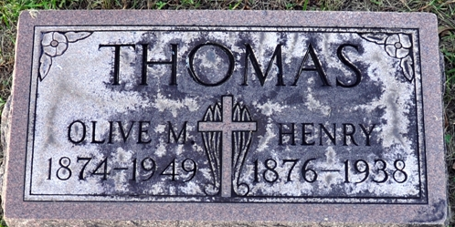
Photo by Deb Curry

Mrs. Olive M. Thomas, 75, widow of the late Henry Thomas, and a former prominent Decatur resident, died suddenly of a heart attack at 11:30 a. m. Sunday at the home of her daughter, Mrs. Portia Vega, 2027 South Fifth Ave., Maywood, Ill.
Mrs. Thomas had made her home with the daughter since the death of her husband. Decatur cigar manufacturer, several years ago.
She was born in Decatur Feb. 17, 1874. a daughter of David and Martha King, graduated from Decatur High School in 1893, and was married Dec. 26, 1899.
Mrs. Thomas was a member of the First Presbyterian Church, and the Royal Neighbors and Pocahontas Lodges. Surviving in addition to the daughter is a sister, Mrs. A. J. Slagal of Marion.
Funeral services will be held at 2 p. m. Wednesday at the Black Funeral Home, the Rev. A. C. E. Gillander officiating. Burial will be in the Decatur Cemetery. Friends may call at the funeral home after 2 p. m. Tuesday.
Decatur Daily Democrat; Adams County, Indiana
Monday, May 9, 1949
**
Olive May King from tree Bell Family Tree
Birth Feb 1874 Decatur, Adams, Indiana, USA
Marriage 26 Dec 1899 Decatur, Adams, Indiana, USA
Residence 1930 Decatur, Adams, Indiana, USA
Death May 9, 1949 Adams, Indiana, USA
Father David King (1836-1882)
Mother Sarah J. Sewell (1838-1892)
Spouse Henry Thomas (Born 1876)

