Margaret E. (Iddings) Thomas
June 25, 1903 – July 25, 1979

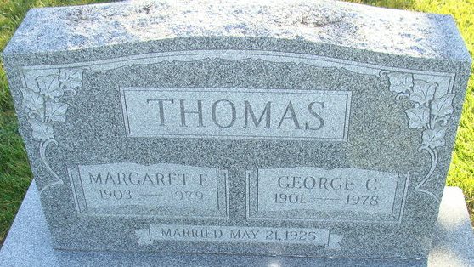
Photo by Deb Curry

Margaret E. Thomas
in the Indiana, U.S., Death Certificates, 1899-2017
Name Margaret E. Thomas
[Margaret E. Iddings]
Gender Female
Race White
Marital Status Widowed
Age 76
Birth Date 25 Jun 1903
Birth Place Ohio
Death Date 25 Jul 1979
Death Place Decatur, Adams, Indiana, USA
Death Registration Date 1979
Father Myron Iddings
Mother Bertha Ingle
Informant Neil Thomas; Lafayette, Indiana
Burial July 28, 1979; Decatur Cemetery; Decatur, Indiana

