Henry Thomas
August 24, 1876 – July 14, 1938

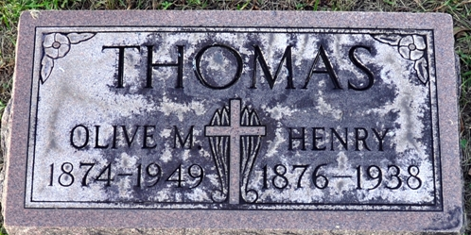
Photo by Deb Curry

Henry Thomas
in the Indiana, U.S., Death Certificates, 1899-2017
Name Henry Thomas
Gender Female
Race White
Marital Status Married
Age 65
Birth Date 24 Aug 1872 [sic]
Birth Place Indiana
Death Date 14 Jul 1938
Death Place Decatur, Adams, Indiana, USA
Death Registration Date 1938
Father Nicholas Thomas
Mother Barbra Meyers
Informant Mrs. Henry Thomas; Decatur, Indiana
Burial July 16, 1938; Decatur Cemetery

