Glenn Louis Thomas
February 21, 1892 – November 3, 1963

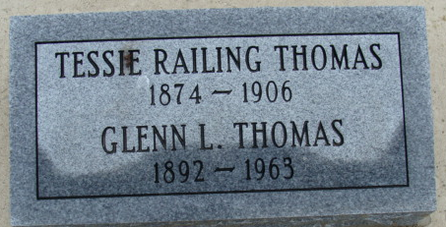

Glenn L Thomas
in the Ohio, U.S., Death Records, 1908-1932, 1938-2022
Name Glenn L Thomas
Gender Male
Race White
Marital Status Divorced
Death Age 71
Birth Date Abt 1892
Residence Place Middletown, Butler, Ohio, USA
Death Date 3 Nov 1963
Death Place Middletown (Pt), Butler, Ohio, USA
Certificate Number 88761
Inquest Hospital Home
Inquest Questions Certifier: Coroner; Autopsy Performed?: Yes, Used For Certification;
**
Indiana, U.S., Marriage Certificates, 1960-2012
Name Glen Louis Thomas
Gender Male
Race White
Marriage Age 30
Birth Date 21 Feb 1892
Birth Place Adams, Indiana
Marriage License Date 14 Feb 1922
Marriage Date 22 Feb 1922
Marriage Place Allen, Indiana, USA
Residence Place Fort Wayne, Indiana
Father Ira Thomas
Mother Tessa Railing
Spouse Helen Martha Steck
Officiator J W Potter

