George Clair Thomas
December 19, 1901 – March 31, 1978

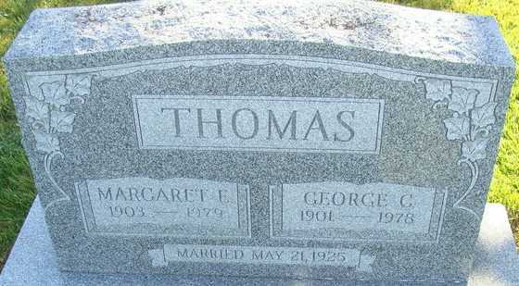

George Clair Thomas
in the Indiana, U.S., Death Certificates, 1899-2017
Name George Clair Thomas
Gender Male
Race White
Marital Status Married
Age 76
Birth Date 19 Dec 1901
Birth Place Ohio
Death Date 31 Mar 1978
Death Place Decatur, Adams, Indiana, USA
Death Registration Date 1978
Father Marvin Thomas
Mother Edna Mishler
Spouse Margaret Idding
Informant Margaret Thomas; Decatur, Indiana
Burial April 2, 1978; Decatur Cemetery; Decatur, Indiana

