Emma Estella (Hart) Thomas
February 6, 1863 – April 8, 1922

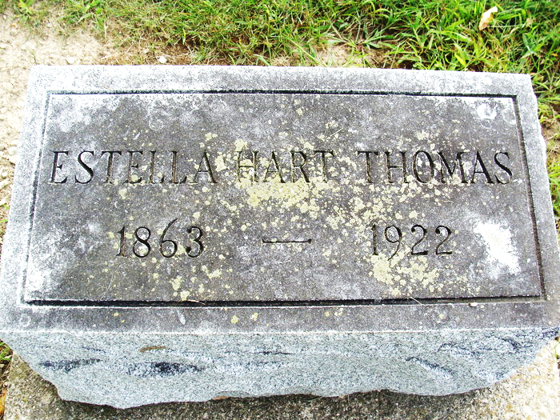
Photo by Alicia Kneuss

MRS. P. B. THOMAS DIED ON SATURDAY
Had Suffered Six Weeks from Pneumonia and Complications
WELL KNOWN WOMAN
Husband, Daughter, Son, Grandchildren Survive- Funeral Tuesday
Death relieved the suffering of Mrs. P. B. Thomas Saturday evening at 7:45 o’clock, after a valiant fight from six weeks of suffering from pneumonia and complications which followed. The news of the death of this well-known lady was received with a general expression of regret from citizens of Decatur, who had known her from childhood. Though her death had been expected for the past several days, the announcement was a shock to the friends of the family, and the sympathy of the community is extended to her husband, the daughter, son and grandchildren. Every means known to the medical fraternity, of which Mr. Thomas is himself a member, was done to save the life of Mrs. Thomas, but to no avail.
Emma Estella Hart was born in Monmouth, February 6, 1863, a daughter of Henry H. and Emma (Clark) Hart. Her parents moved into their home at the corner of Third and Adams Street when, she was about one year old, and the daughter lived there until her death Saturday evening. The father died from a wound received in the civil war when Estella was but eighteen months old. A few months after, her mother became a helpless invalid from rheumatism, and the little girl learned early the lesson of self-sacrifice and service to others. She was the only comfort to her mother throughout her life. She was educated in the Decatur Public Schools and from early childhood gave special attention to music, possessing a voice of rare sweetness and beauty. She united with the Methodist Church in Decatur when she was quite young, and played, and sang in the choir for many years. June 11, 1885, she was united in marriage to Dr. P. B. Thomas and to this union were born two children.
She leaves the husband, one daughter, Carrie Haubold, one son, Bryce, a student at Purdue University; three grandchildren, Helen, Tommy and Louise, to whom she was greatly devoted, and they deeply mourn their loss. There is also one brother, Harry E. Hart, of San Francisco, California,
She was a woman who was beloved by all who knew her, possessing a sweet and sunny disposition. Her friends were innumerable, and their expressions of love and regard, and hope for her recovery were a great joy to her during her illness. She suffered six long weeks, but kept her courage and cheerfulness to the end, always hoping that she might recover to care for her home and family at least a few more years.
Funeral services will be held Tuesday afternoon at 2:30 from the home, the Rev. Charles Tinkham officiating, with burial at the Decatur cemetery. Friends may view the remains this evening from 7 to 9 o’clock and from 8 to 10 Tuesday morning.
Decatur Daily Democrat, Adams County, Indiana
Monday, April 10, 1922

**
Emma Estella Hart was born in Monmouth., Ind. Feb. 6, 1863 and died in Decatur, April 8, 1922 aged 59 years, 1 months and 2 days. She was the laughter of Henry H. and Emma A. Hart. Her parents moved into their home on the corner of Third and Adams Streets, Decatur, when she was about one year old, and she continued to live there all her life. Her father died of wounds received in the Civil War when she was about 18 months old. A few years later her mother became a helpless cripple from rheumatism, and the little girl early learned the lesson of self-sacrifice and service to others. She was the only comfort to her mother throughout her life.
Estella was educated in the Decatur public schools and from early childhood gave special attention to music, possessing a voice of rare sweetness and beauty. She united with the Methodist church of this city November 5, 1886 under the pastorate of the Rev. Thomas Stables, S. S. and played and sang in the choir for many years. She was united in marriage with Dr. P. B. Thomas June 11th, 1885. To this union were born two children.
Mrs. Thomas leaves her husband, her daughter. Mrs. Carrie Haubold, her son, Bryce and three little grandchildren, Helen, Tommy and Louise Haubold to whom she was devoted, to deeply mourn her loss. She was a woman beloved by all who knew her, possessing a sweet sunny disposition, tact and sympathy. Her friends were innumerable, and their expressions of love and regard, and hope for her recovery were a great joy to her during her illness. She suffered for six long weeks but kept her courage and cheerfulness to the end always hoping that she might recover to care for her family for at least a few more years. She had a long hard fight but the Father called her and she had to go. It Is with great sorrow that we lose her, but we know that she Is resting peacefully now as a reward for the spotless life she lived.

Decatur Daily Democrat, Adams County, Indiana
Wednesday, April 12, 1922

