Raymond M. Thieme
December 25, 1927 – December 2, 2003

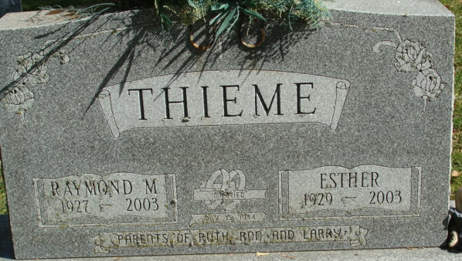
Photo by Alicia Kneuss

Raymond M. Thieme, 75, of Decatur, passed away Tuesday, Dec. 2, 2003.
News-Sentinel, Allen County, Indiana
Thursday, December 4, 2003
**
Indiana, U.S., Death Certificates, 1899-2017
Name Raymond M Thieme
Gender Male
Race White
Marital Status Widowed
Age 75
Birth Date 25 Dec 1927
Birth Place Adams County, Indiana
Death Date 2 Dec 2003
Death Place Decatur, Adams, Indiana, USA
Death Registration Date 2003
Father Richard Thieme
Mother Sophia Hockemeyer
Informant Ruth Ann Hutker; daughter; Decatur, Indiana
Burial December 5, 2003; Decatur Cemetery; Decatur, Indiana

