Larry L. Thieme
September 19, 1962 – June 27, 2012

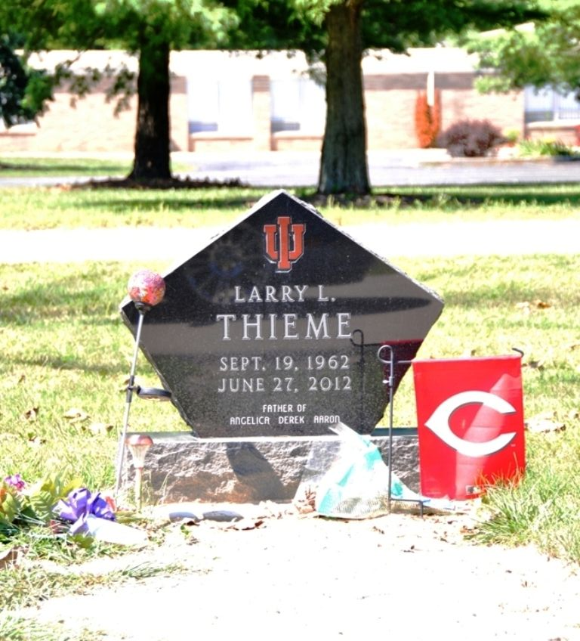
Photo by Deb Curry

Larry L. Thieme, 49 years old of Decatur, Indianan, was found deceased in his semi-truck in Kilgore, Texas, apparently from natural causes on Wednesday, June 27, 2012. His death was unexpected.
Larry was born on Wednesday, September 19, 196 in Decatur, Indiana the son of the late Raymond Thieme and the late Esther (Werling) Thieme.
Larry was a member of the Zion Lutheran Church in Decatur, Indiana.
Larry was employed by PAM Trucking as an over the road truck driver for the past two years. He was formerly employed at the Decatur K-Mart for many years.
Surviving are his daughter, Angelica (Tory) Fuelling of Decatur; son, Derek Thieme of Decatur; son, Aaron Thieme of Decatur; sister, Ruth (Alan) Hutker of Decatur; brother, Ron Thieme of Decatur; former wife Teresa Thieme of Decatur.
Funeral services will be held at 10:30 a.m. Tuesday, July 3, 2012 in the Zwick & Jahn Funeral Home with Rev Robert Becker and DCE Daniel Henz officiating. Interment will follow in the Decatur Cemetery. Friends will be received from 2-4 and 5-8 p.m. Monday, July 2, 2012 in the Zwick and Jahn Funeral Home Decatur and one hour prior to the service at the funeral home on Tuesday.
Preferred memorials are to the Children's Education Fund.

Zwick & Jahn Funeral Home, Adams County, Indiana
June 28, 2012
**
U.S., Cemetery and Funeral Home Collection, 1847-Current
Name Larry L. Thieme
Gender Male
Death Age 49
Birth Date 19 Sep 1962
Birth Place Decatur, Indiana
Residence Place Decatur, Indiana
Death Date 27 Jun 2012; Death Place Kilgore, Texas
Burial Date 3 Jul 2012
Father Raymond Thieme
Mother Esther Thieme
Spouse Teresa Thieme
Child Angelica Fuelling, Aaron Thieme, Derek Thieme
Siblings Ruth Hutker, Ron Thieme

