Gilbert Thieme
March 29, 1917 – May 30, 2006

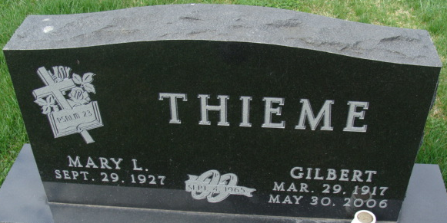
Photo by Alicia Kneuss

Gilbert Thieme, 89 years old of Decatur, Indiana, passed away on Tuesday, May 30, 2006 in Adams Memorial Hospital, Decatur. He was born on Thursday, March 29, 1917 in Adams County, Indiana the son of the late Anton Thieme and the late Louise (Selking) Thieme. Gilbert married Norma Wefel on May 21, 1939 and she passed away on February 19, 1959. He then married Mary Louise (Crosby) Kenney on September 4, 1965 and she survives.
Gilbert was a member of Zion Lutheran Church, Decatur, Indiana and a former active member of Immanuel Lutheran Church where he served as the financial secretary and was an elder. He was in the Lutheran Layman’s League and active in the Gold Crown Bowling League. As a young man Gilbert served as a page at the State House in Indianapolis. He loved to pitch horseshoes and play euchre.
Gilbert was a retired farmer and had also been employed by Scott's Foods since 1988, retiring in 2005 with 16 years of service. He had also previously worked at the Schafer Company, Leo Thieme Construction, and Otto Thieme Drainage.
Surviving are his wife, Mary Louise Thieme of Decatur, Indiana, son, Lanny G. Thieme of North Olmsted, Ohio, daughter, Mrs. Bud (Beverly) Case of Decatur, Indiana, daughter, Karen Reidenbach of Frankfort, Indiana, daughter, Mrs. Dennis (Susan) Baker of Coldwater, Michigan, step-son, John W. (Pam) Kenney of Decatur, Indiana, step-daughter, Mrs. Donald (Kate) Steuernagel of Chula Vista, California, step-daughter, Mrs. Daniel T. (Julie) Miller of Decatur, Indiana, step-daughter, Ms. Laura Kenney of Decatur, Indiana, twenty-one grandchildren, twenty-four great-grandchildren.
Gilbert was preceded in death by two step-sons, James M. Kenney & Patrick E. Kenney, son-in-law, James Reidenbach, granddaughter, Leigh Anne Steuernagel, step great-granddaughter, Lindsey Arnold and twin sister, Elsie Buuck.
Funeral services will be held at 11:00 a.m. Monday, June 5, 2006 in the Zion Lutheran Church, Decatur with Rev. Scott Bruick officiating. Interment will follow in the Decatur Cemetery. Friends will be received from noon to 5:00 p.m. and 6:00 p.m. to 8:00 p.m., Sunday, June 4 at the Zwick & Jahn Funeral Home, Decatur, and on Monday from 10:00 a.m. until the service at the Zion Lutheran Church.
Preferred memorials are to Zion Lutheran Church, Worship for Shut-Ins, or the Zion Lutheran Radio Fund.
Zwick & Jahn Funeral Home, Adams County, Indiana
May 31, 2006

