Esther (Werling) Thieme
May 1, 1929 – March 2, 2003

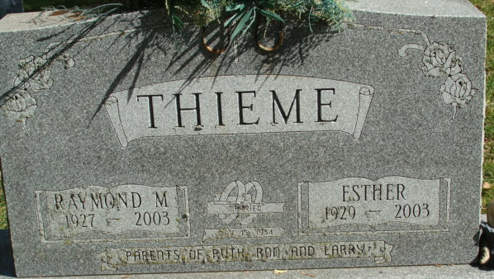
Photo by Alicia Kneuss

Esther Thieme, 73, of Decatur, a homemaker, died Sunday, March 2, 2003, at Adams County Memorial Hospital. The Adams County native was a member of Zion Lutheran Church.
Surviving is her husband, Raymond; a daughter, Ruth Ann Hutker of Decatur; sons Ron A. and Larry L., both of Decatur; brothers Edwin and Gerhard Werling, both of Decatur; eight grandchildren; one step-grandchild; two great-grandchildren; and two step-great-grandchildren.
She was preceded in death by a brother.
Services are 10 a.m. Thursday at Zwick & Jahn Funeral Home, Decatur, with calling from 2 to 4 and 6 to 8 p.m. Wednesday. Burial will be at Decatur Cemetery.
Memorials are to Zion Lutheran School 7th and 8th Grade Class Trip.
News-Sentinel, Allen County, Indiana
Tuesday, March 4, 2003

**
Indiana, U.S., Death Certificates, 1899-2017
Name Esther Thieme
[Esther Werling]
Gender Female
Race White
Marital Status Married
Age 73
Birth Date 1 May 1929
Birth Place Adams County, Indiana
Death Date 2 Mar 2003
Death Place Decatur, Adams, Indiana, USA
Death Registration Date 2003
Father Gottlieb Werling
Mother Christena Fuhrman
Spouse Raymond Thieme
Informant Ruth Ann Hutker; daughter; Decatur, Indiana
Burial March 6, 2003; Decatur Cemetery; Decatur, Indiana

