Edwin H. Thieme
December 5, 1897 – April 5, 1968

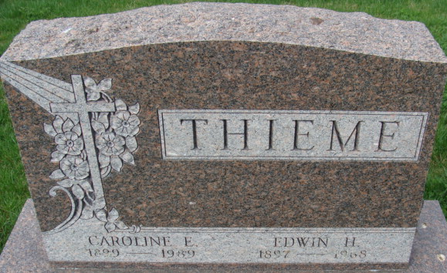
Photo by Alicia Kneuss

Edwin H Thieme
in the Indiana, U.S., Death Certificates, 1899-2017
Name Edwin H Thieme
Race White
Marital Status Married
Age 70
Birth Date 5 Dec 1897
Birth Place Indiana
Death Date 5 Apr 1968
Death Place Decatur, Adams, Indiana, USA
Death Registration Date 1968
Father Theodore Thieme
Mother Caroline Schamerloh
Spouse Caroline Ewell
Informant Mrs. Caroline Thieme; wife; Decatur, Indiana
Burial April 9, 1968; Decatur Cemetery; Decatur, Indiana

