Caroline (Ewell) Thieme
November 28, 1899 – March 8, 1989

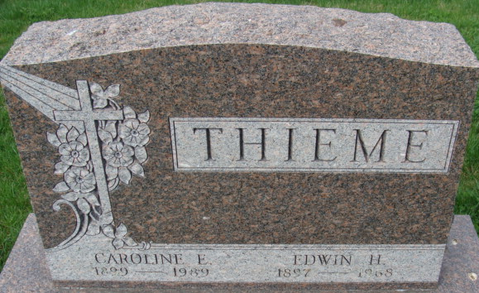
Photo by Alicia Kneuss

Caroline E Thieme
in the Indiana, U.S., Death Certificates, 1899-2017
Name Caroline E Thieme
[Caroline E Ewell]
Gender Female
Race White
Marital Status Widowed
Age 89
Birth Date 28 Nov 1899
Death Date 8 Mar 1989
Death Place Fort Wayne, Allen, Indiana, USA
Death Registration Date 1989
Father Theodore Ewell
Mother Elise Kipp
Informant Eileen Vorndran; daughter; Fort Wayne, Indiana
Burial March 11, 1989; Decatur Cemetery; Decatur, Indiana

