Lowell Lee Thatcher
December 16, 1958 -

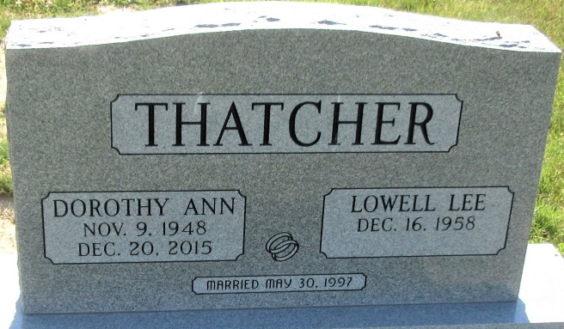
Photo by PLS

