Joseph W. Thatcher
July 27, 1931 – May 8, 2005

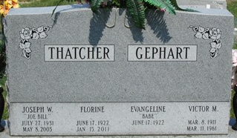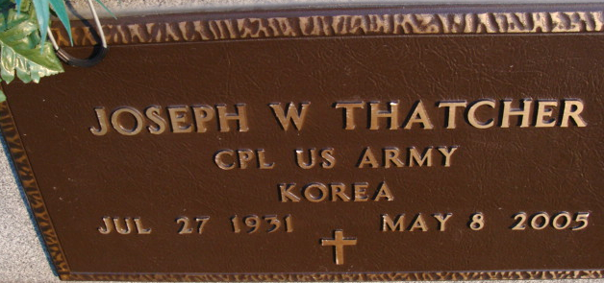
Photo by Randy Gephart

Decatur, IN – Joseph W. Thatcher, 73, of Decatur, died Sunday, May 8, 2005, at his residence. Born July 27, 1931, in Adams County, he was the son of Delbert Thatcher and Catherine Banning. He married D. Florine Everett on Oct. 1, 1960.
He retired after 40 years of service with United Telephone Co. He was a member of American Legion Post 207 Homer Pierson, Willshire, Ohio; Moose Lodge 1311; Van Wert 40 & 8; first president of C.W.A. Union 5782; and served with the 82nd U.S. Airborne in the Korean War.
Surviving are his wife, D. Florine Thatcher of Decatur; two sons, Rex Thatcher of Decatur and Kerry Thatcher of Van Wert, Ohio; one daughter, Lei Lonnee R. (Brad) Taylor of Convoy, Ohio; seven sisters, Wanita Cable, Virgie Lister, Virginia (Harold) VanHorn and Mary (Donald) Dick, all of Decatur, Marjorie (Larry) Hileman, Elsie (Lowell) Beougher and Darlene (Conley) Marsee, all of Rockford, Ohio; one brother, Gene (Vivian) Thatcher of Willshire, Ohio; three grandchildren; and two great-grandchildren. He was preceded in death by three brothers, Alvin "Bub", Preston B. and Reynold Thatcher, two sisters, Bonnie Ellison and Rosie Johnson.
Service is 10:30 a.m. Friday at Decatur Cemetery, with graveside Military services by American Legion Post 207 Homer Pierson, Willshire, Ohio.
Memorials to American Legion Post 207 Homer Pierson, Willshire, Ohio.
***
THATCHER, JOSEPH W.: Service is 10:30 a.m. today at Decatur Cemetery, with graveside Military services by American Legion Post 207 Homer Pierson, Willshire, Ohio.

News-Sentinel, Allen County, Indiana
May 11, 2005

