Edith Gertrude Thatcher
February 18, 1898 – April 9, 1915

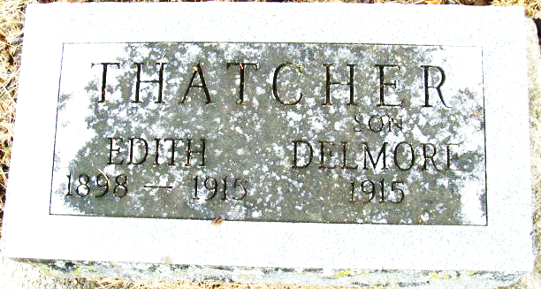
Photo by Alicia Kneuss

GENEVA CHILD DEAD
Miss Edith Thatcher, sixteen, a native of Geneva, but who has made her home with Mr. and Mrs. Chronover in St. Mary's Township, Adams County, died Friday of heart trouble.
She is survived by the father and a sister, Nellie, who live in Michigan, and another sister, Mrs. Lottie Gephart of Adams County.

Bluffton Chronicle, Wells County, Indiana
April 14, 1915

**
Indiana, Death Certificates, 1899-2011
Name: Edith Gertrude Thatcher
Gender: Female
Race: White
Age: 17 years, 1 month, 22 days
Marital status: Single
Birth Date: 18 Feb 1898
Birth Place: Adams
Death Date: 9 Apr 1915
Death Place: St Mary’s, Adams, Indiana , USA
Father: James Thatcher
Informant: Mrs. Geneva Crownover; Decatur, Ind.
Burial: April 11, 1915; Decatur Cem.

