Dorothy Ann (Newbauer) Thatcher
November 9, 1948 – December 20, 2015

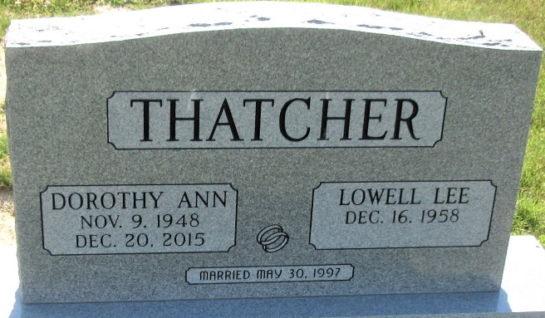
Photo by PLS

Dorothy Ann Thatcher, 67 years old of Decatur, Indiana, passed away on Sunday, December 20, 2015 in the Adams Memorial Hospital located in Decatur. Dorothy was born on November 9, 1948 in Greenville, Ohio the daughter of the late William Newbauer and the late Mary Ellen (DeCamp) Newbauer.
Dorothy was a former church janitor at the Decatur Church of Christ. Following her tenure at the church, she was also employed at Silberline in Decatur as a janitor. Dorothy loved football and her team was the Pittsburgh Steelers. She was a really great listener and her children fondly remember those times that she would listen and provide good advice.
Surviving are her son, Ronald B. Smith of Decatur, IN; son, George M. (fiancé Alexis Bryant) Dearden of Kokomo, IN; sister, Marilynn Hofacker of Celina, OH; brother, William Newbauer of St. Mary's, OH.
Preceding Dorothy in death was one sister, Mary Alice Weaver and one brother, Denny Newbauer.
Funeral services will be held at 12:00 Noon Tuesday, December 22, 2015 in the Zwick & Jahn Funeral Home. Interment will follow in the Riverside Cemetery, Rockford, Ohio (sic). Friends will be received from 10:00 a.m. - 12:00 Noon Tuesday, December 22, 2015 in the Zwick & Jahn Funeral Home, Decatur, IN.

Zwick & Jahn Funeral Home, Adams County, Indiana
December 21, 2015
**
Indiana, U.S., Death Certificates, 1899-2017
Name Dorothy Ann Thatcher
Maiden Name Newbauer
Gender Female
Race White
Age 67
Birth Date 9 Nov 1948
Birth Place Greenville, Ohio
Death Date 20 Dec 2015
Death Place Decatur, Adams, Indiana, USA
Death Registration Date 2015
Father William Newbauer
Mother Mary Decamp
Spouse Lowell Lee Thatcher
Informant Lowell Lee Thatcher; husband; Decatur, Indiana
Burial Decatur Cemetery; Decatur, Indiana
Certificate Number 059730

