Delmore Rolland Thatcher
March 22, 1915 – March 22, 1915

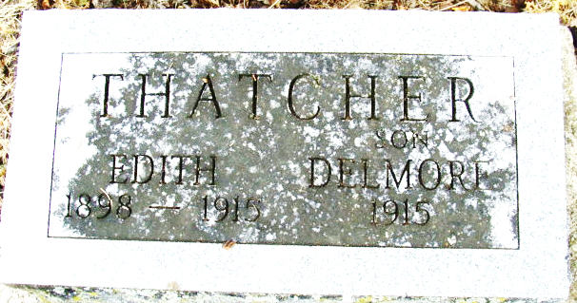
Photo by Alicia Kneuss

Delmore Ralland Thatcher from tree Byrd / Schwartz Family Tree
Birth 22 Mar 1915 Adams, Indiana, USA
Death 22 Mar 1915 Adams, Indiana, USA
Father Leroy Franklin Thomas (1878-1956)
Mother Edith Gertrude Thatcher (1898-1915)

