Sarah (Brunner) Teeter
August 27, 1892 – October 18, 1974

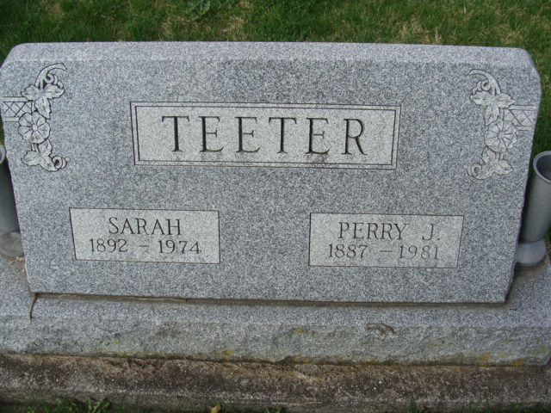
Photo by Alicia Kneuss

Sarah Teeter passes away
Mrs. Sarah Teeter, 82, of 1237 Elm St., died at 2:55 p.m. Friday at the Adams county memorial hospital, where she had been a patient six weeks.
Born in French township on August 27, 1892, she was the daughter of Emil and Lena Riff-Brunner, and was married on May 10, 1913, to Perry J. Teeter, who survives.
Also surviving are four children, Mrs. Louis (Marie) Litterer of Gallipolis, O.; Mrs. Paul (Lena) Schmitz of Santa Barbara, Calif.; Mrs. James (Phyllis) Reed of Florrisant, Mo.; Harold Teeter of Decatur; one sister, Mrs. Aldine Beer of route 1, Berne; and 13 grandchildren. One sister and four brothers preceded her in death.
Funeral services will be held at 1:30 p.m. Monday at the Winteregg-Linn and Haggard funeral home, with Rev. Matthew Worthman officiating. Burial will be in the Decatur cemetery. Friends may call at the funeral home after 10 a.m. Sunday.
Decatur Daily Democrat, Adams County, Indiana
Saturday, Oct. 19, 1974

