Perry J. Teeter
March 22, 1887 – February 25, 1981

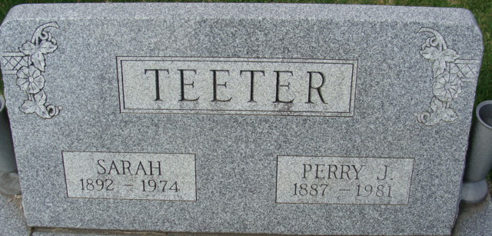
Photo by Alicia Kneuss

Perry J. Teeter
in the Indiana, U.S., Death Certificates, 1899-2017
Name Perry J. Teeter
Gender Male
Race White
Marital Status Widowed
Age 93
Birth Date 22 Mar 1887
Birth Place Indiana
Death Date 25 Feb 1981
Death Place Decatur, Adams, Indiana, USA
Death Registration Date 1981
Father John Teeter
Mother Martha Baker
Informant Harold Teeter; Decatur, Indiana
Burial February 28, 1981; Decatur Cemetery; Decatur, Indiana

