Hazel V. (Springer) Teeter
October 11, 1897 – November 19, 1989

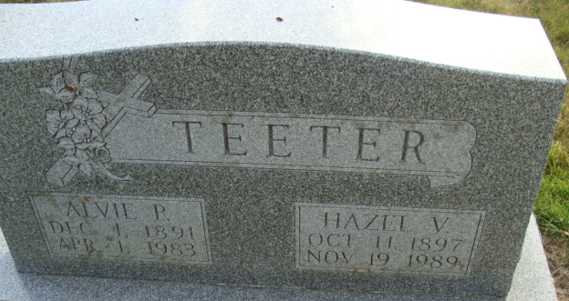
Photo by Alicia Kneuss

Hazel V Teeter
in the Indiana, U.S., Death Certificates, 1899-2017
Name Hazel V Teeter
[Hazel V Springer]
Gender Female
Race White
Marital Status Widowed
Age 92
Birth Date 11 Oct 1897
Birth Place Adams County, Indiana
Death Date 19 Nov 1989
Death Place Decatur, Adams, Indiana, USA
Death Registration Date 1989
Father Perry Springer
Mother Martha E Maloney
Informant Kathryn Schug; daughter; Geneva, Indiana
Burial November 22, 1989; Decatur Cemetery; Decatur, Indiana

